**User Engagement Report Module**

**Description**

User engagement report module is a tool to handle and manage large number of application users with summarised and concise report overview.

It is a management platform which helps a company manage and get overview of User traffic report, individual user report and registered user report with graphs and charts.

**Typical Usage Scenario**

Problem Statement:

* Overview of users traffic within a day/months/year.
* Individual user detail report
* Registered users report which give information about how many users have been created in a month.

**PreRequisites**

NA

**Features and Limitations**

* User Traffic: 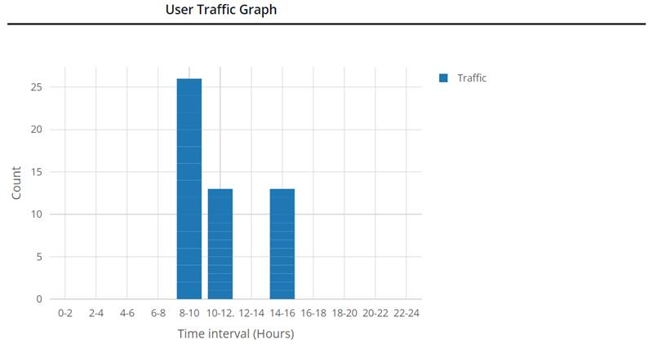

This chart summarised all the user’s login traffic during a day which is divide in the 12 intervals.

* Individual User detail report: 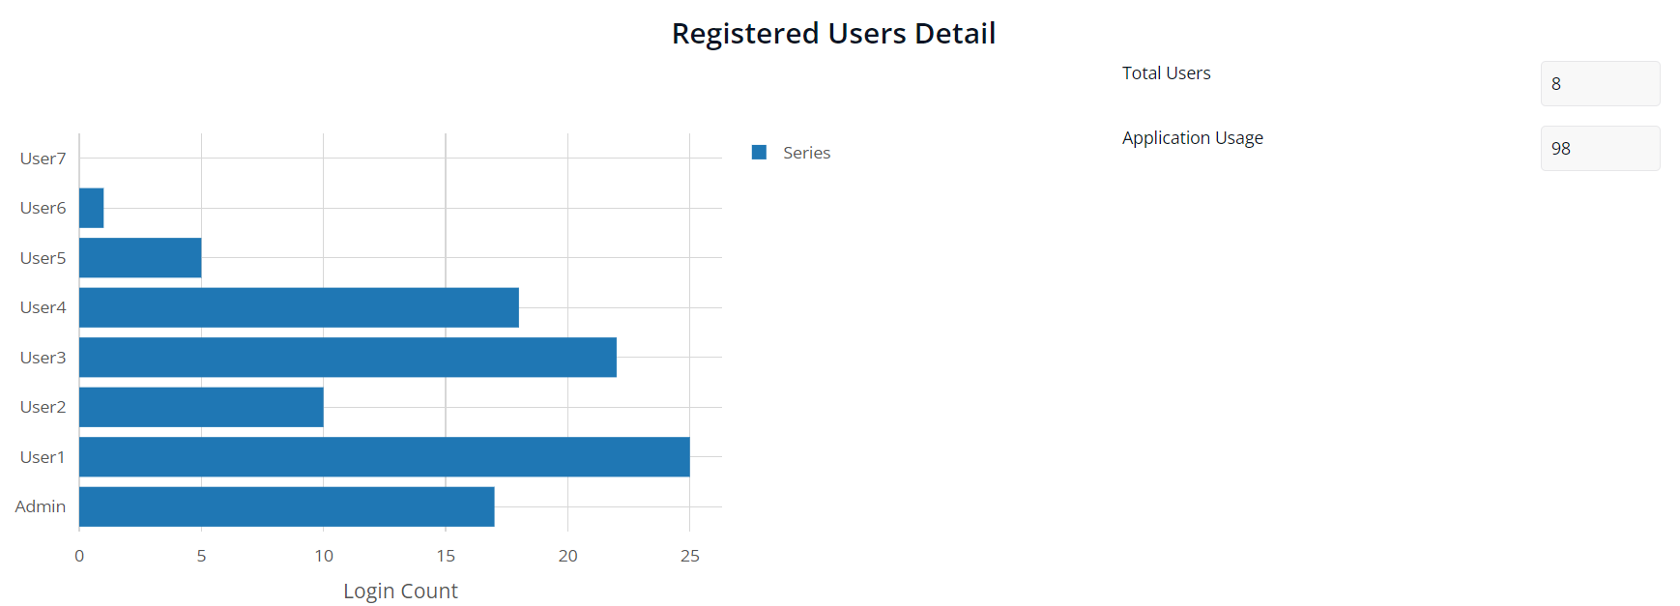

This chart summarized the individual user traffic within a day with total user and total users login count in a day.

* Registered user report: 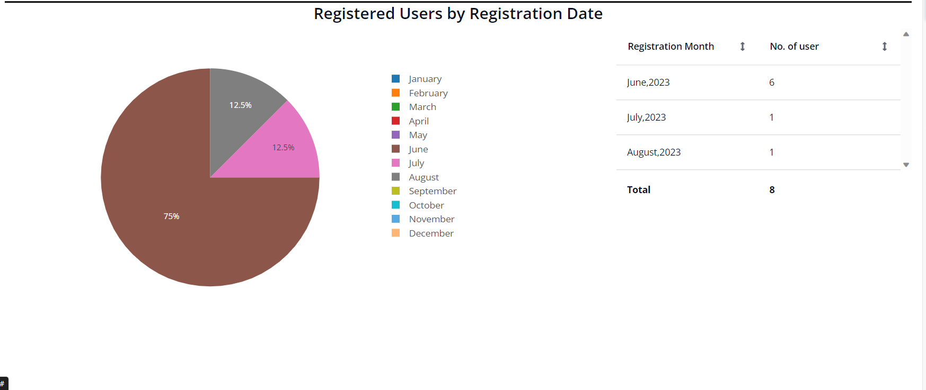

This pie chart summarized the total user registered count within a particular month along with summary.

**Dependencies**

1. Require Mendix 9.24.1 or above.

# **Installation**

* Import the module from marketplace.
* After importing set the microflow ‘ACT_CountLogin’ as a default home page microflow in the navigation.
* Create a new item in navigation and set the activity as show a page and call the page ‘Dashboard’ in USE_ME folder.

**Configuration: NA**

**Category: Module**

**Subcategory: All**

**Visibility: Public Marketplace**

**Studio Pro Version: 9.24.1**